**Assignment 10**

**Name:** Jeevan Sai Badana

Mail: [jeevansai100@gmail.com](mailto:jeevansai100@gmail.com)

Date: 01-02-2024

Topic:Pandas

**Pandas for Data Processing:**

**Data Framing:**

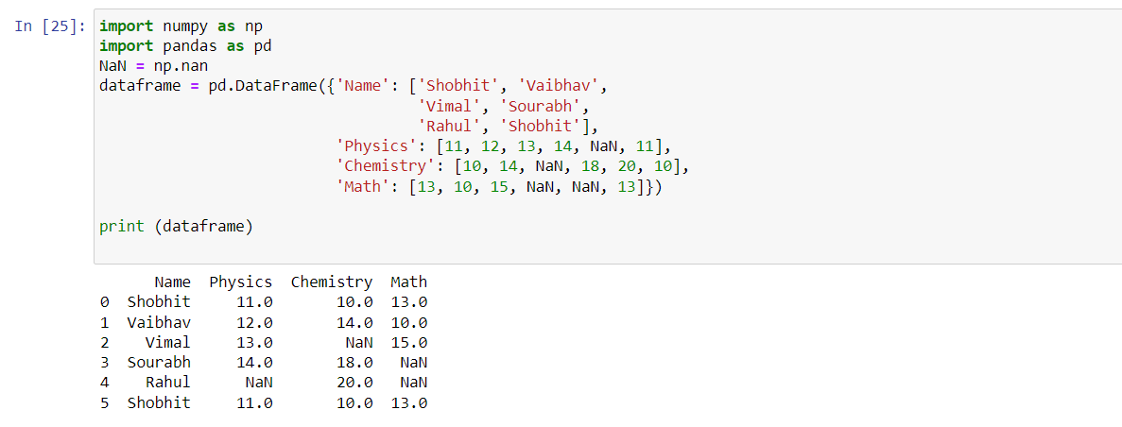

**Using count() function:**

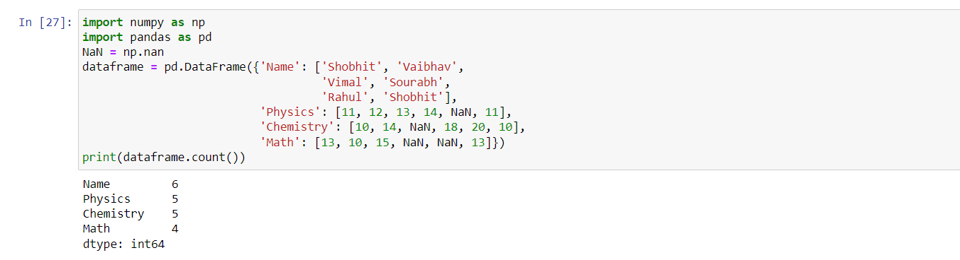

**axis='columns' to count with respect to row:**

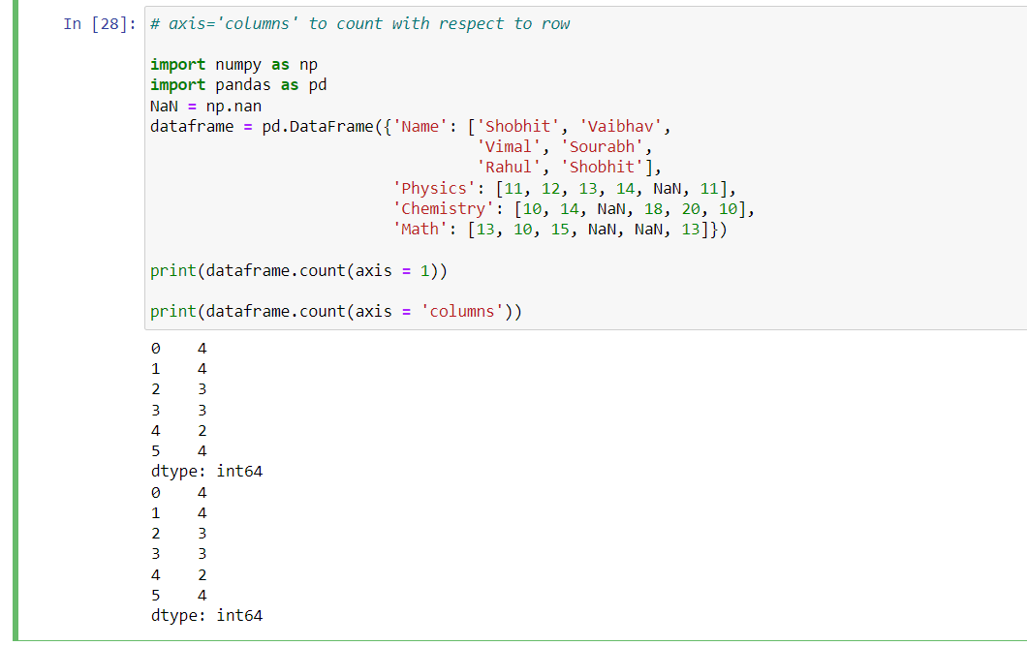

**Now if we want to count null values in our dataframe.**

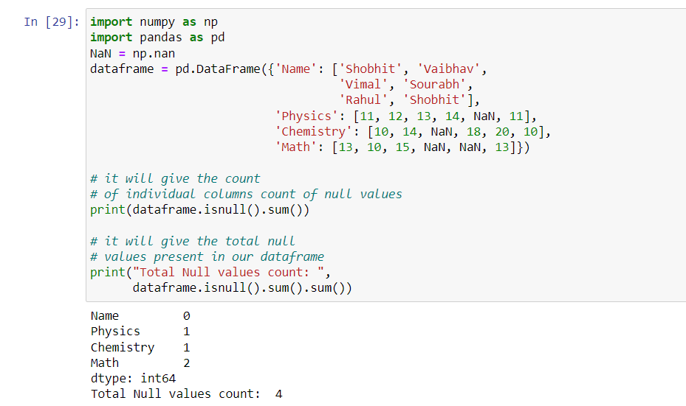

**Reading CSV Data using Pandas**

* **Using pd.read_csv**

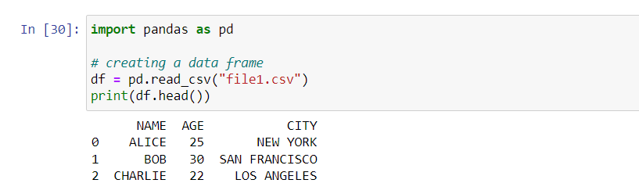

* **Using pd.read_table**

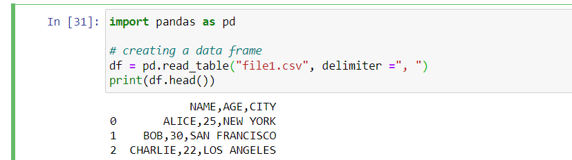

* **Using the csv module**

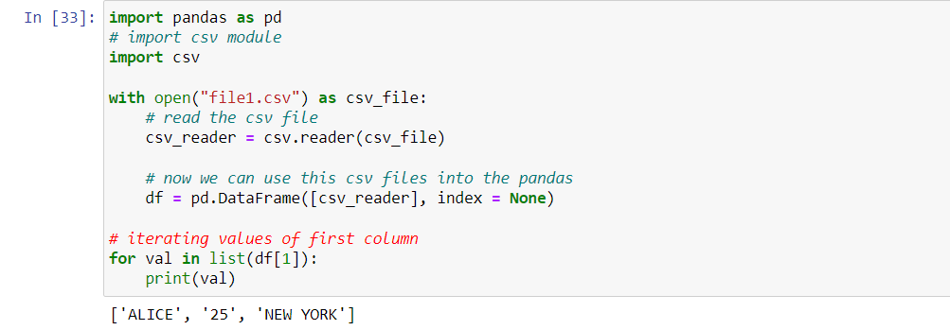

**JOINS**

**Inner join:**

* For this purpose we create two dataframes data frame a and data frame b and we perform inner joins

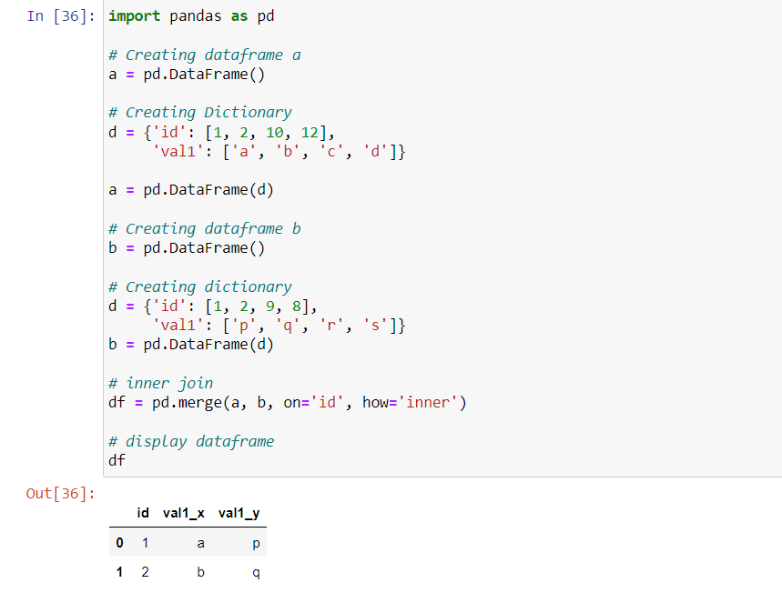

**Left join:**

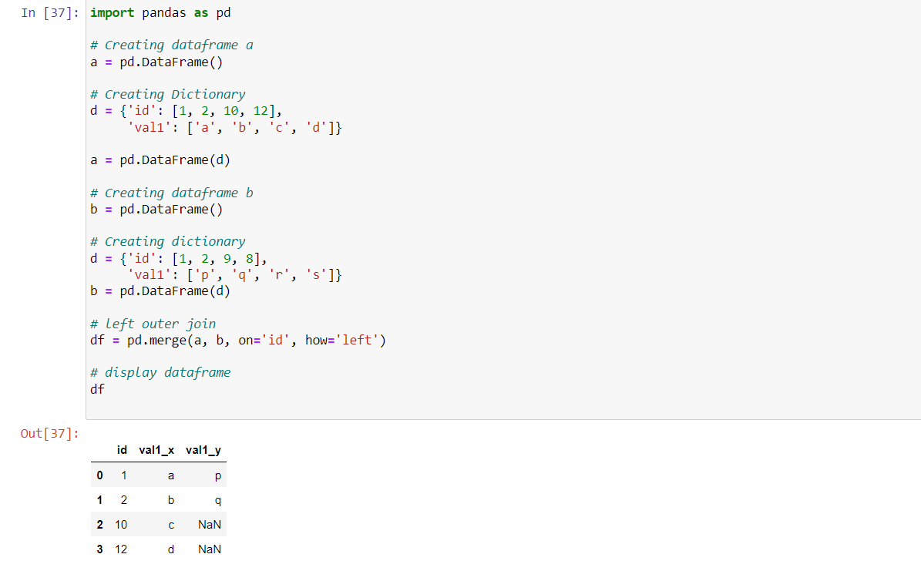

**Right join:**

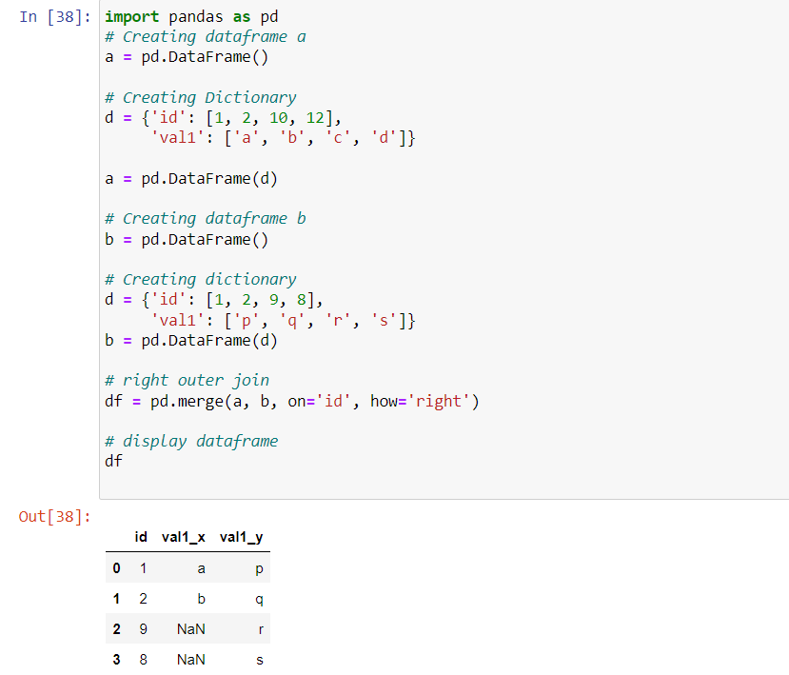

**Pandas Full Outer Join:**

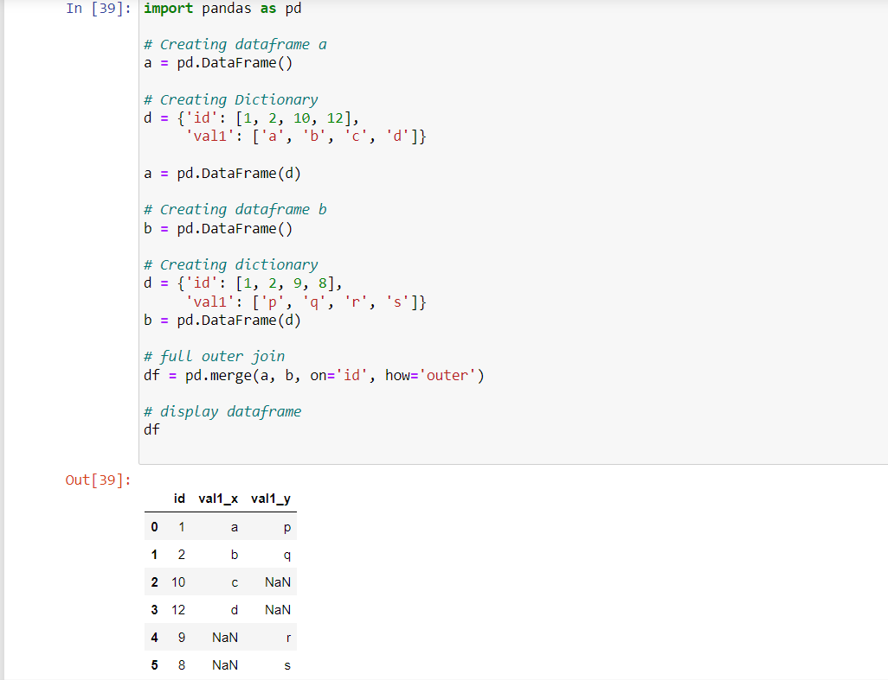

**Creating numpy arrays:**

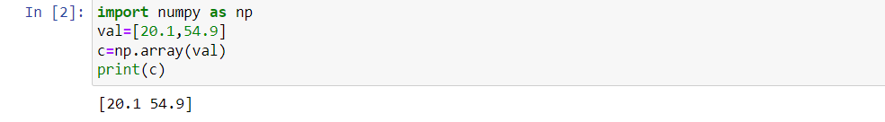

**Performing operations**

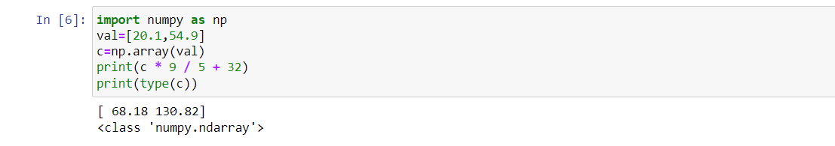

**Using range function**

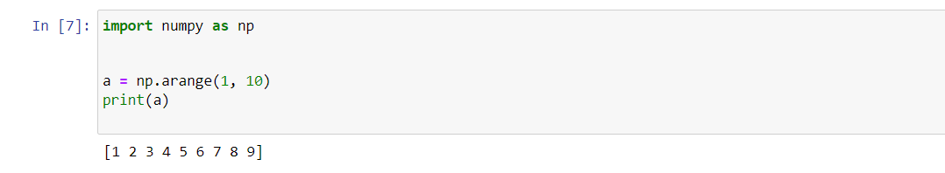

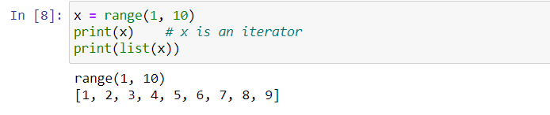

**Range using start,stop and step**

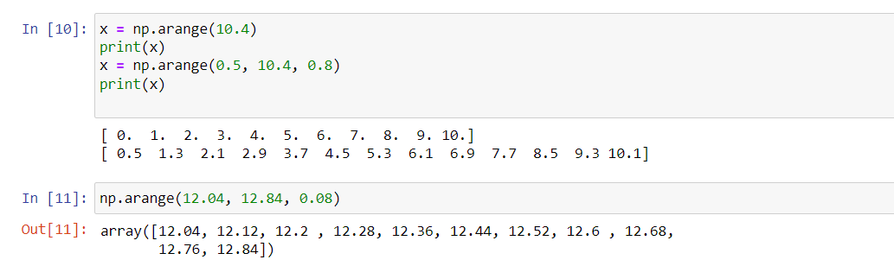

**Using linspace**

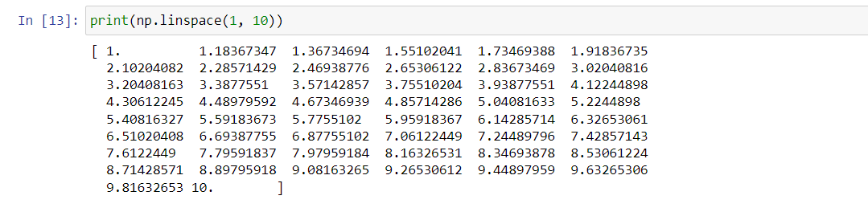

**Using linspace with range and endpoint**

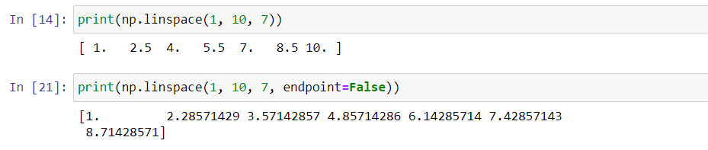

**Using linspace with retstep:**

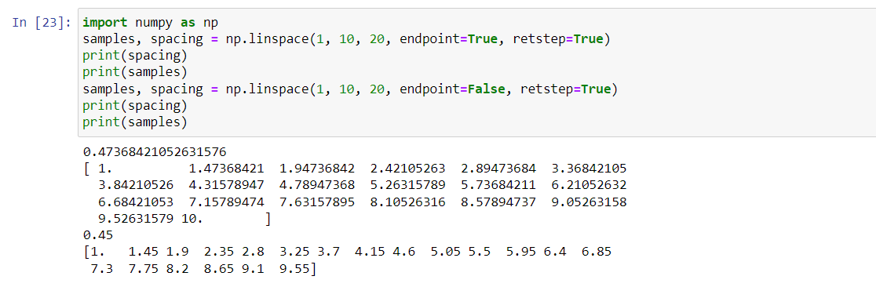

**Using samples and spacing**

